**Project Development Phase Sprint - 4**

|  |  |
| --- | --- |
| Date | 14-11-2022 |
| Team ID | PNT2022TMID44624 |
| Project Name | Signs with Smart Connectivity for Better Road  Safety |

Image – 1: Web-UI

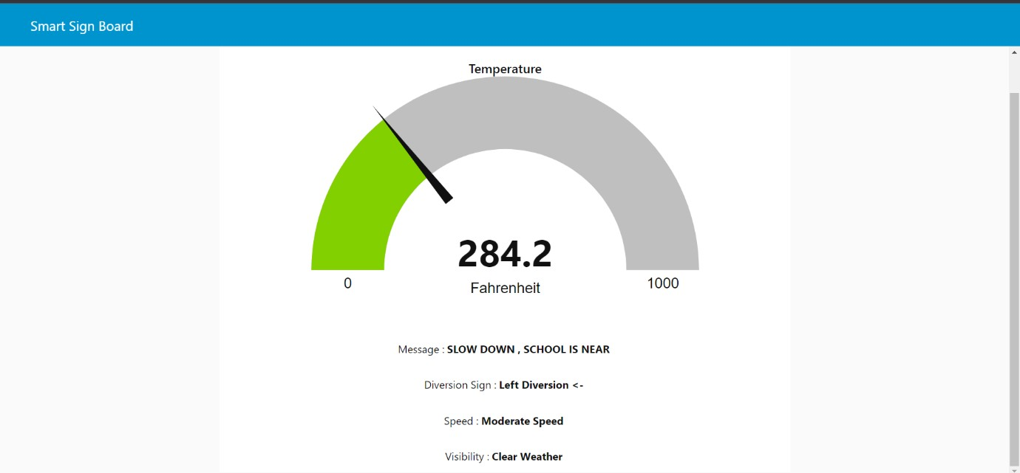

Image – 2: Node-red

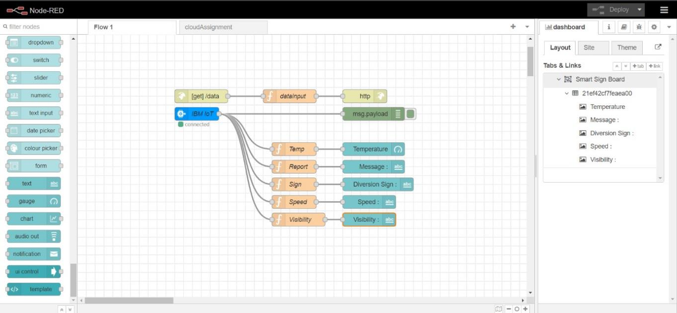

Image – 3: IOT Device output

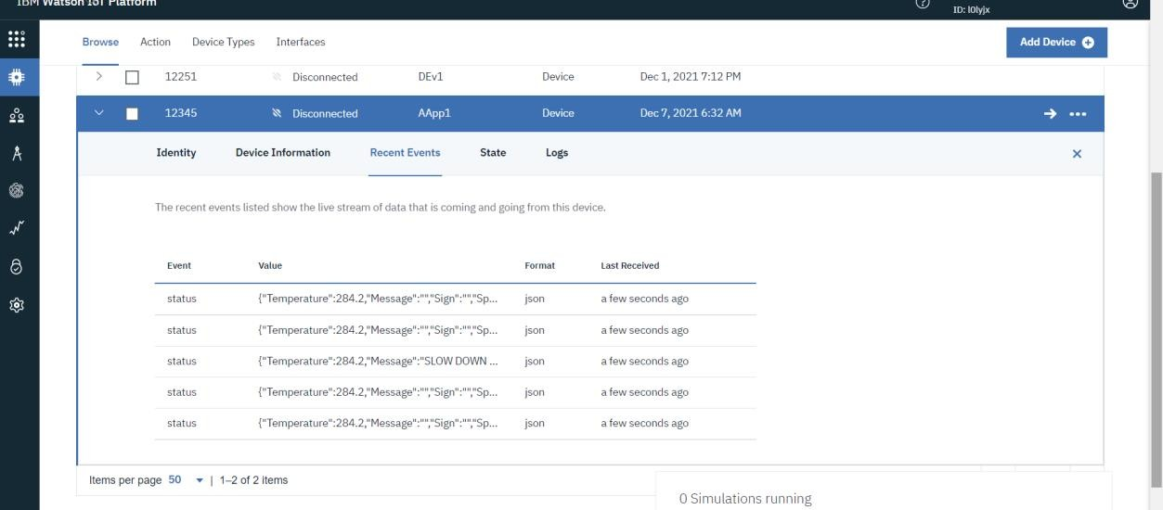

Image – 4: MIT App inventor Front end

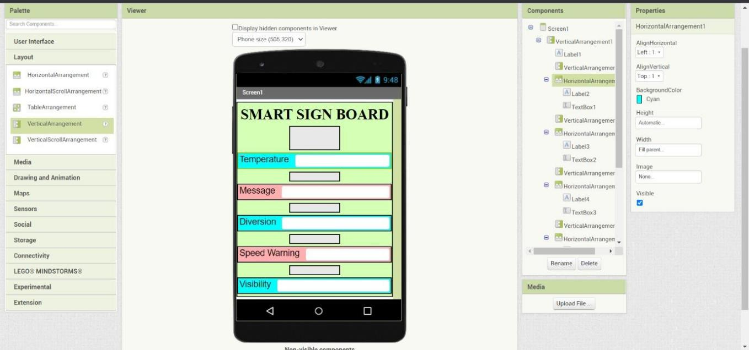

Image – 5: MIT App inventor Backend

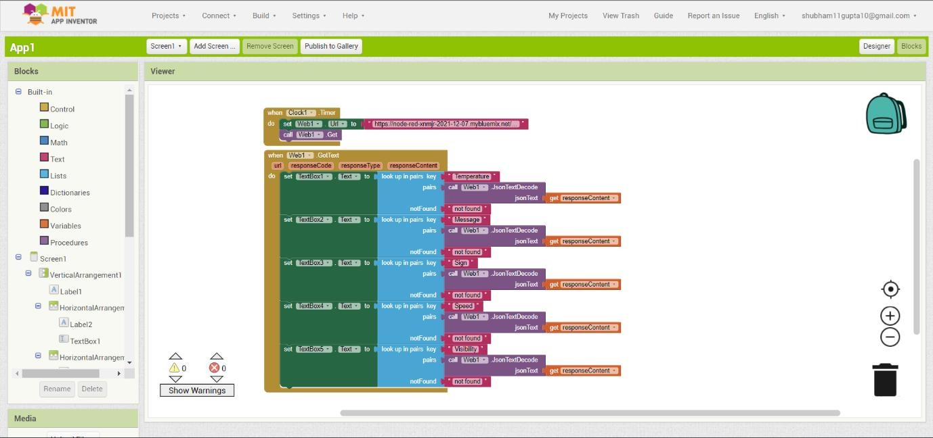

Image – 6: Pycode output

